Stanley Park Bike Rentals

By: David Scott, Sam New, Keith Noseworthy, and Grant Yao.

# Functional Requirements

## Essentials

* Application/ log in form for users (to track information)
* Payment
  + Liability warning
* Bike information database
  + photos, specifications, (*status*), price
* Contact(s)
  + store information, contact information
* Map database
  + Route planning?
* Social media
  + Twitter, Facebook, Tripadvisor

## Important

* Admin/user purchase history

## Extra

* Addition of rollerblades in database
* Dining combos

# Non-Functional Requirements

* Logos
* Colour scheme

# Use Case Diagram

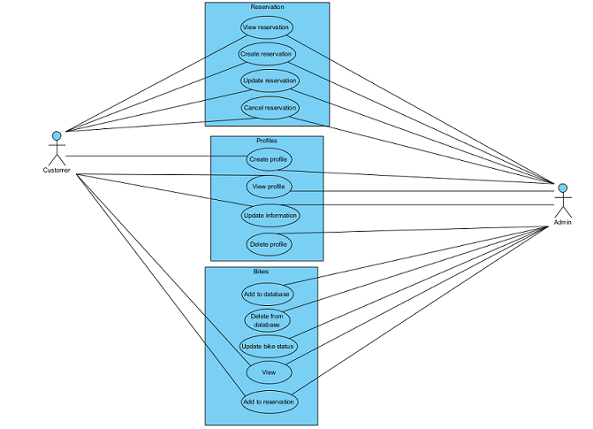

# CRUD ANALYSIS

|  |  |  |  |
| --- | --- | --- | --- |
| **Use Case** | **Entity** | **CRUD** | **Actors** |
| Create Reservation | Reservation | Create | Customer/Admin |
| Update Reservation | Reservation | Update | Customer/Admin |
| Cancel Reservation | Reservation | Delete | Customer/Admin |
| View Reservation | Reservation | Read | Customer/Admin |
| Create Profile | Profiles | Create | Customer/Admin |
| Update Information | Profiles | Update | Customer/Admin |
| Delete Profile | Profiles | Delete | Admin |
| View Profile | Profiles | Read | Customer/Admin |
| Add to Database | Bikes | Update | Admin |
| Delete from Database | Bikes | Delete | Admin |
| Update Bike Status | Bikes | Update | Admin |
| View Bike | Bikes | Read | Customer/Admin |
| Add Bike to Reservation | Bikes | Update | Customer/Admin |

# ENTITY RELATIONSHIP DIAGRAM

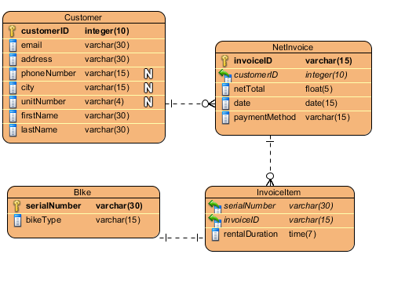

SITE MAP  
  
